**Selenium**

**Day 7**

**Task 1:**

package com.day7;

import org.openqa.selenium.WebDriver;

import org.openqa.selenium.chrome.ChromeDriver;

import org.openqa.selenium.chrome.ChromeOptions;

import org.testng.Assert;

import org.testng.annotations.Test;

public class Task1 {

@Test

public void Google() {

System.setProperty("webdriver.chrome.driver","c://Drivers//chromedriver.exe" );

ChromeOptions co=new ChromeOptions();

co.addArguments("--remote-allow-origin=*");

WebDriver driver=new ChromeDriver(co);

driver.get("https://demo.wpeverest.com/user-registration/guest-registration-form/");

String actualtitle=driver.getTitle();

System.out.println(actualtitle);

String expectedtitle="Guest Registration Form – User Registration";

Assert.assertEquals(actualtitle,expectedtitle);

}

}

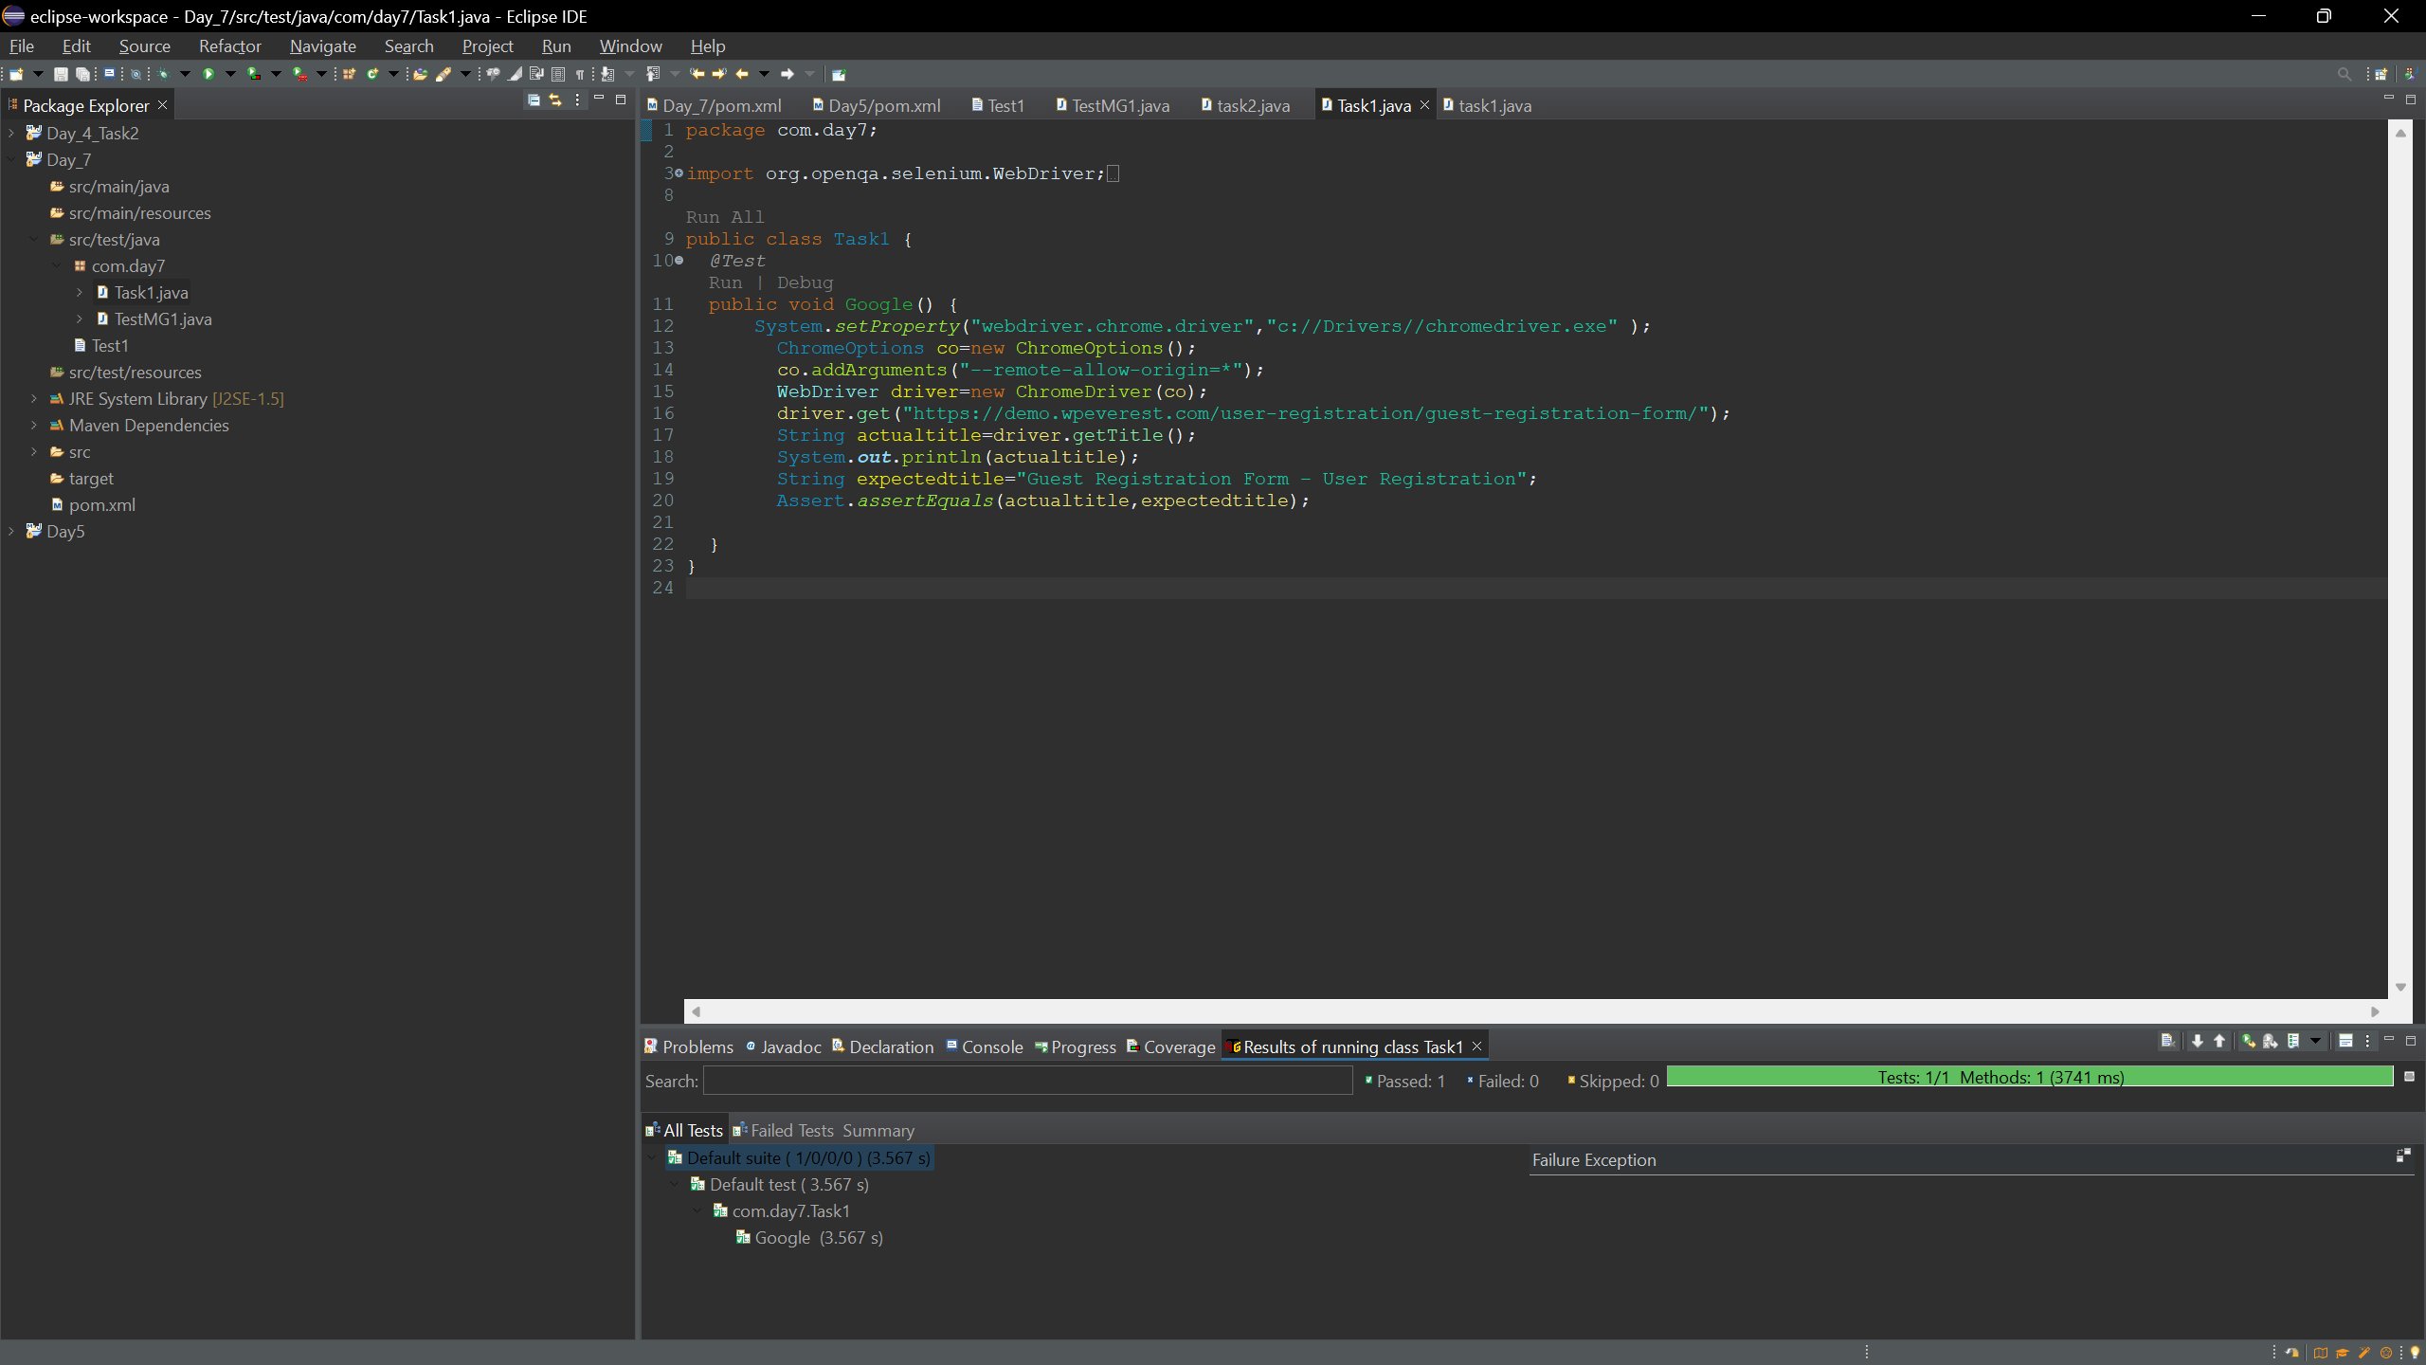

**Output:**

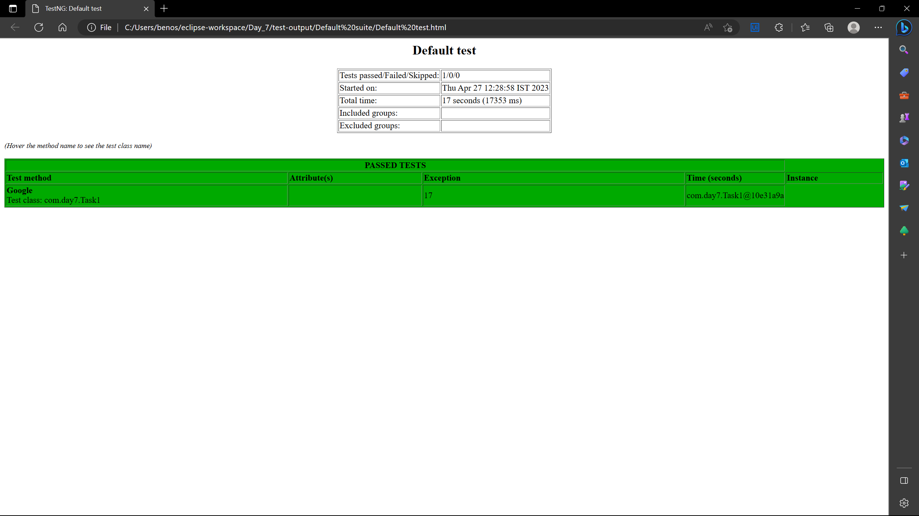

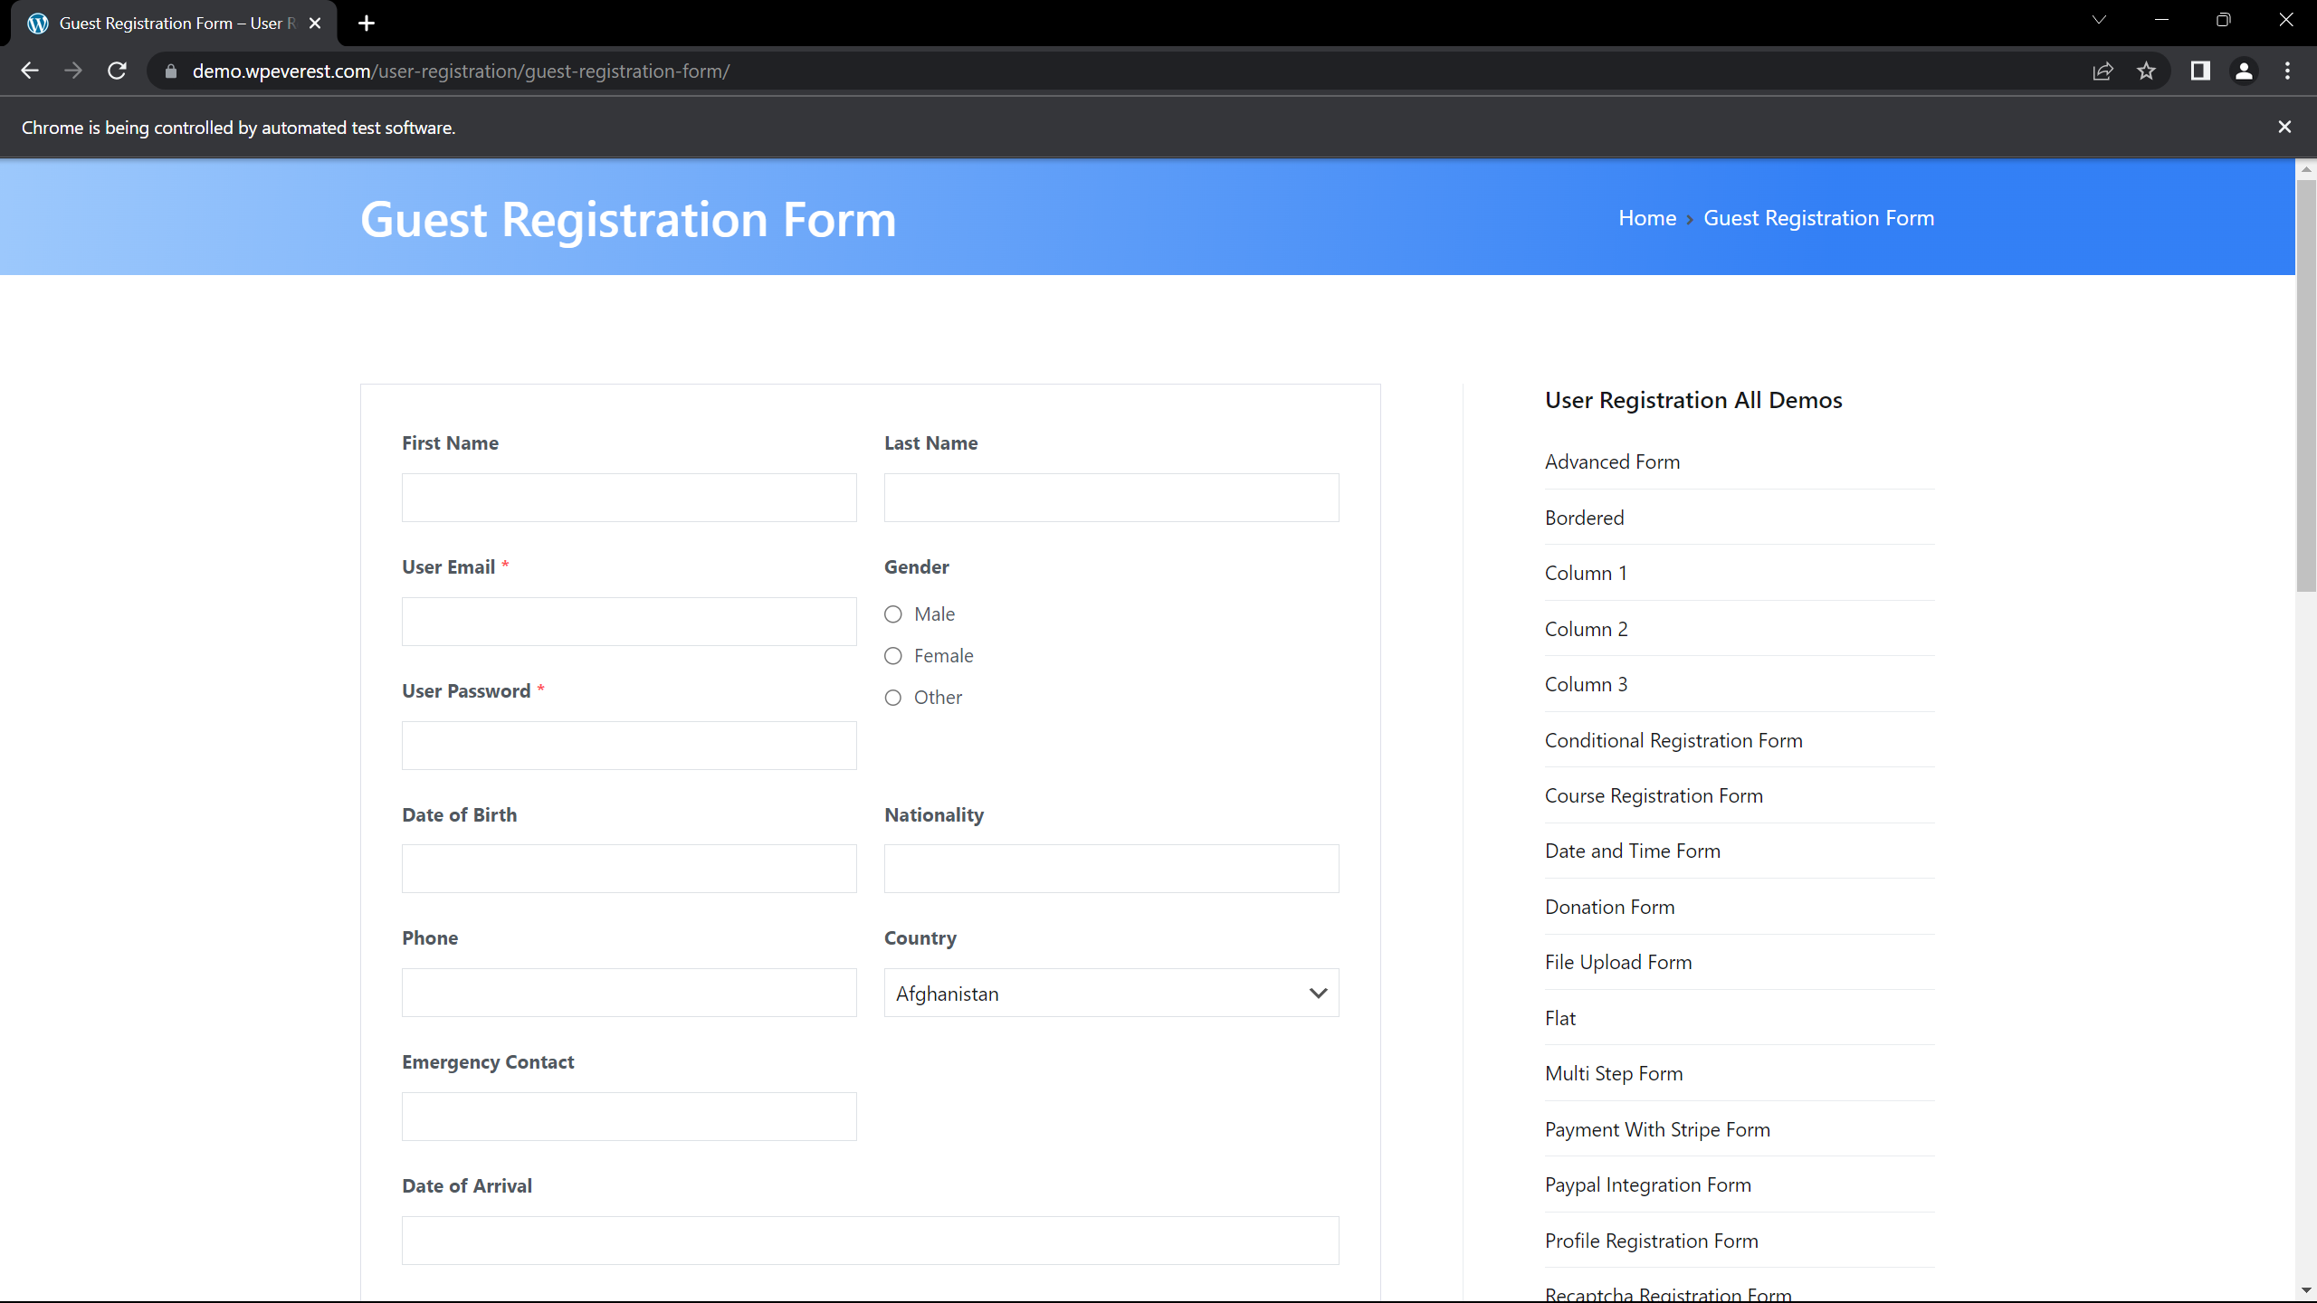

**Task 2:**

package com.day7;

import org.testng.Assert;

import org.testng.annotations.BeforeSuite;

import org.testng.annotations.Test;

public class Task2 {

int a,b,c;

*@BeforeSuite*

public void getdata() {

a=7;

b=4;

}

*@Test*(priority=4)

public void add() {

c=a+b;

Assert.*assertEquals*(c, 11);

}

*@Test*(priority=3)

public void sub() {

c=a-b;

Assert.*assertEquals*(c, 3);

}

*@Test*(priority=1)

public void mul() {

c=a*b;

Assert.*assertEquals*(c, 28);

}

*@Test*(priority=2)

public void div() {

c=a/b;

Assert.*assertEquals*(c, 1);

}

}

**Output:**

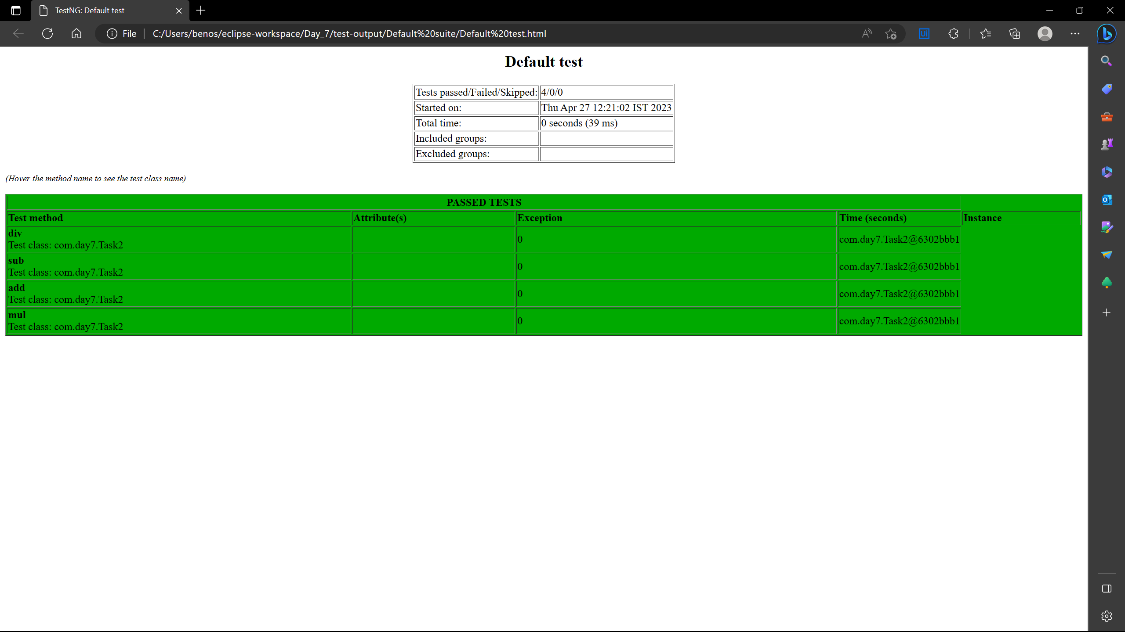

**Task 3:**

package com.day7;

import org.openqa.selenium.By;

import org.openqa.selenium.WebDriver;

import org.openqa.selenium.WebElement;

import org.openqa.selenium.chrome.ChromeDriver;

import org.openqa.selenium.chrome.ChromeOptions;

import org.openqa.selenium.interactions.Actions;

import org.testng.annotations.AfterMethod;

import org.testng.annotations.BeforeMethod;

import org.testng.annotations.Test;

import com.github.dockerjava.api.model.Driver;

import io.github.bonigarcia.wdm.WebDriverManager;

public class Task3 {

WebDriver driver;

*@Test*

public void Test() throws InterruptedException {

Thread.*sleep*(3000);

WebElement Username=driver.findElement(By.*xpath*("//*[@id=\"app\"]/div[1]/div/div[1]/div/div[2]/div[2]/form/div[1]/div/div[2]/input"));

Username.sendKeys("Admin");

WebElement password=driver.findElement(By.*xpath*("//*[@id=\"app\"]/div[1]/div/div[1]/div/div[2]/div[2]/form/div[2]/div/div[2]/input"));

password.sendKeys("admin123");

WebElement btn=driver.findElement(By.*xpath*("//*[@id=\"app\"]/div[1]/div/div[1]/div/div[2]/div[2]/form/div[2]/div/div[2]/input"));

btn.click();

}

*@BeforeMethod*

public void setup() {

//WebDriverManager.chromedriver().setup();

System.*setProperty*("webdriver.chrome.driver","c://Drivers//chromedriver.exe" );

ChromeOptions co =new ChromeOptions();

co.addArguments("--remote-allow-origin=*");

driver=new ChromeDriver(co);

String url="https://opensource-demo.orangehrmlive.com/web/index.php/auth/login";

driver.get(url);

driver.manage().window().fullscreen();

}

*@AfterMethod*

public void teardown() {

driver.close();

}

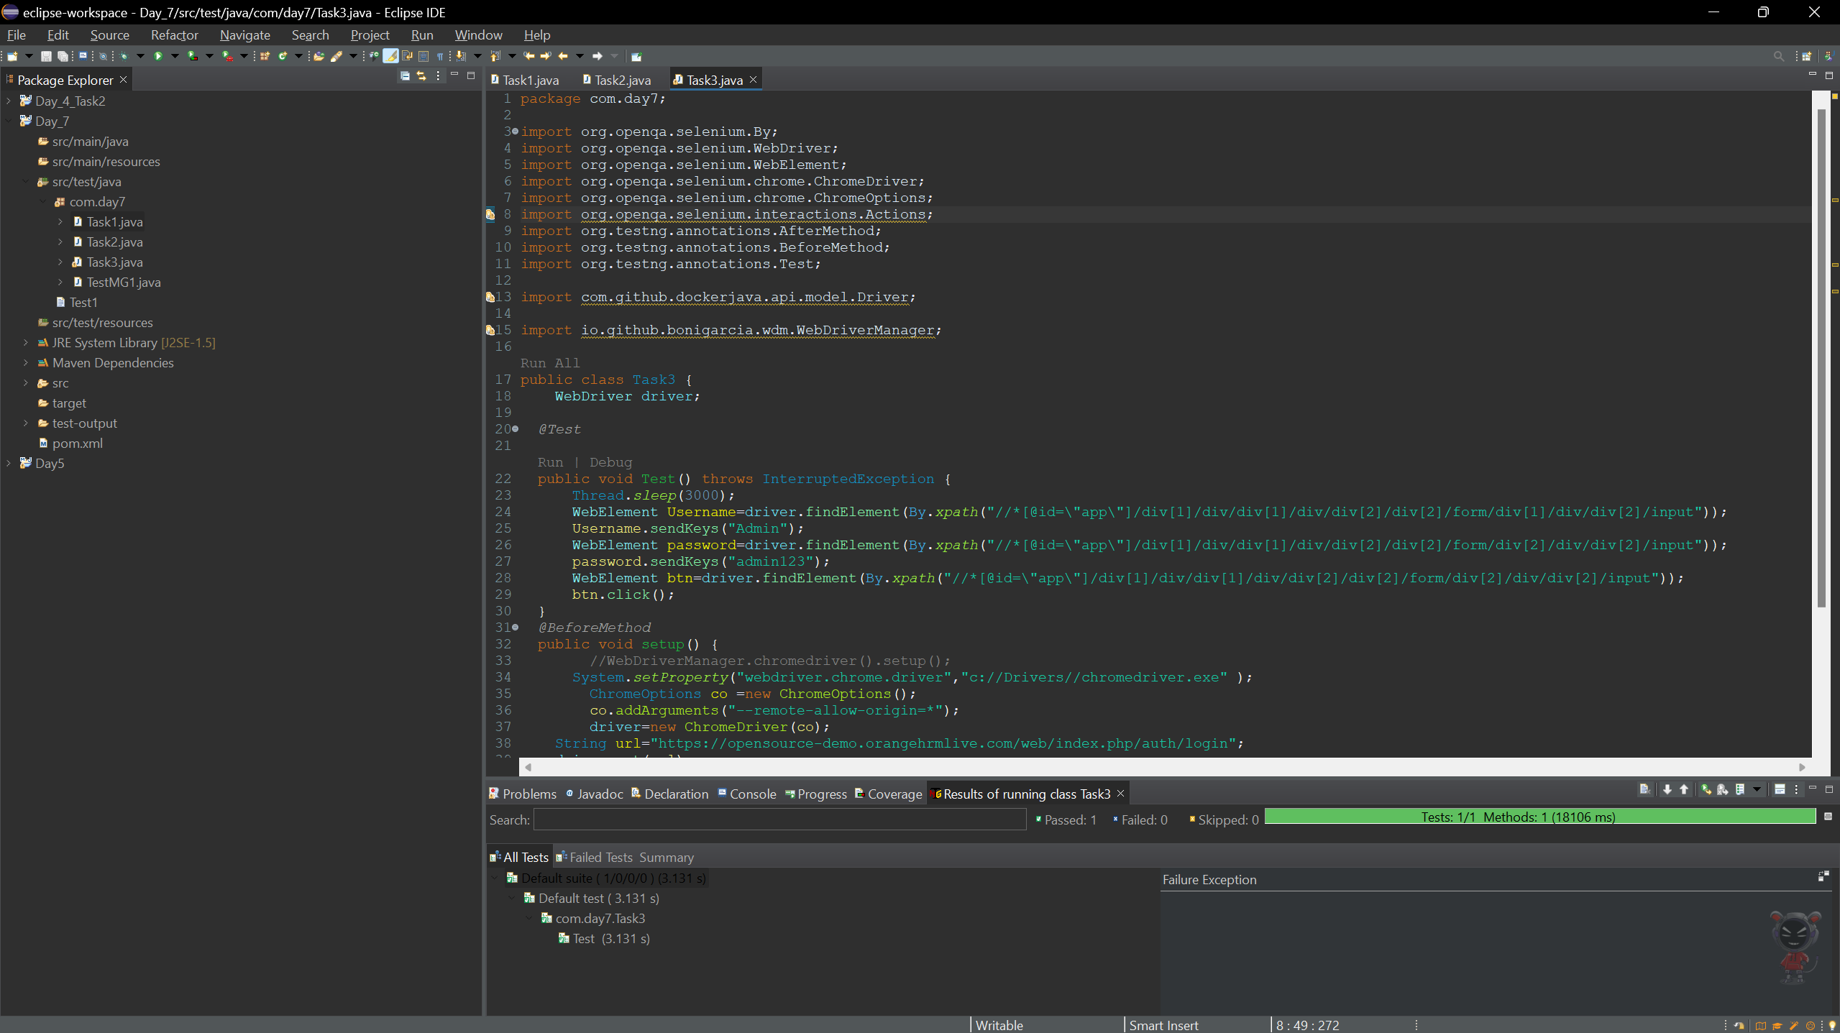

**Output:**

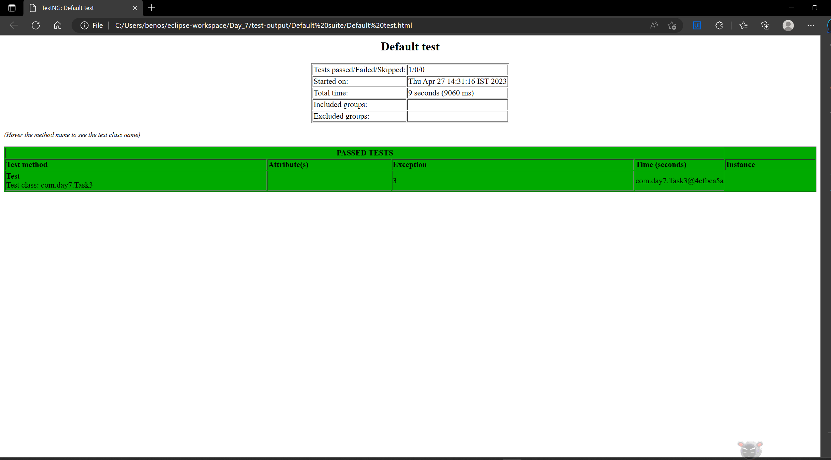

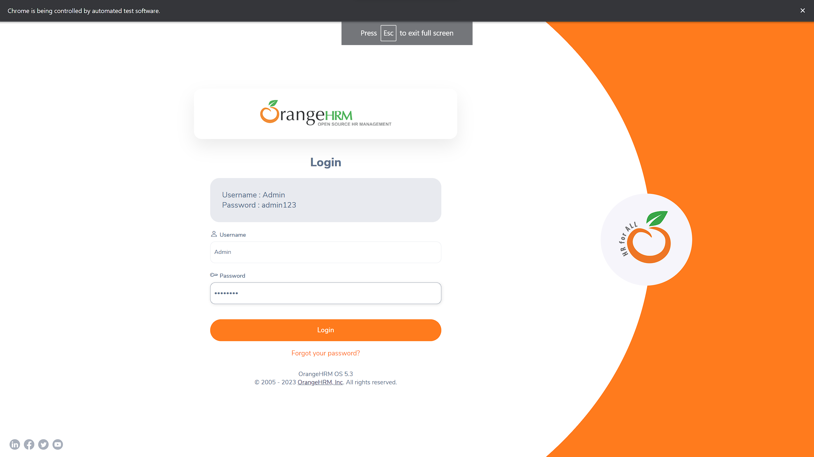

**Task 4:**

package com.day7;

import org.openqa.selenium.By;

import org.openqa.selenium.WebDriver;

import org.openqa.selenium.WebElement;

import org.openqa.selenium.chrome.ChromeDriver;

import org.openqa.selenium.chrome.ChromeOptions;

import org.testng.annotations.BeforeMethod;

import org.testng.annotations.Test;

import io.github.bonigarcia.wdm.WebDriverManager;

public class Task4 {

WebDriver driver;

*@Test*

public void Login() throws InterruptedException {

//WebDriverManager.chromedriver().setup();

System.*setProperty*("webdriver.chrome.driver","c://Drivers//chromedriver.exe" );

ChromeOptions co =new ChromeOptions();

co.addArguments("--remote-allow-origin=*");

driver=new ChromeDriver(co);

String url="https://opensource-demo.orangehrmlive.com/web/index.php/auth/login";

driver.get(url);

driver.manage().window().maximize();

Thread.*sleep*(3000);

WebElement Username=driver.findElement(By.*xpath*("//*[@id=\"app\"]/div[1]/div/div[1]/div/div[2]/div[2]/form/div[1]/div/div[2]/input"));

Username.sendKeys("Admin");

WebElement password=driver.findElement(By.*xpath*("//*[@id=\"app\"]/div[1]/div/div[1]/div/div[2]/div[2]/form/div[2]/div/div[2]/input"));

password.sendKeys("admin123");

WebElement btn=driver.findElement(By.*xpath*("//*[@id=\"app\"]/div[1]/div/div[1]/div/div[2]/div[2]/form/div[3]/button"));

btn.click();

}

// @BeforeMethod

// public void setup() {

//

//

// }

*@Test*(dependsOnMethods="Login")

public void Logut() throws InterruptedException{

Thread.*sleep*(3000);

WebElement PC=driver.findElement(By.*xpath*("//*[@id=\"app\"]/div[1]/div[1]/header/div[1]/div[2]/ul/li/span"));

PC.click();

WebElement logout=driver.findElement(By.*xpath*("//*[@id=\"app\"]/div[1]/div[1]/header/div[1]/div[2]/ul/li/ul/li[4]/a"));

logout.click();

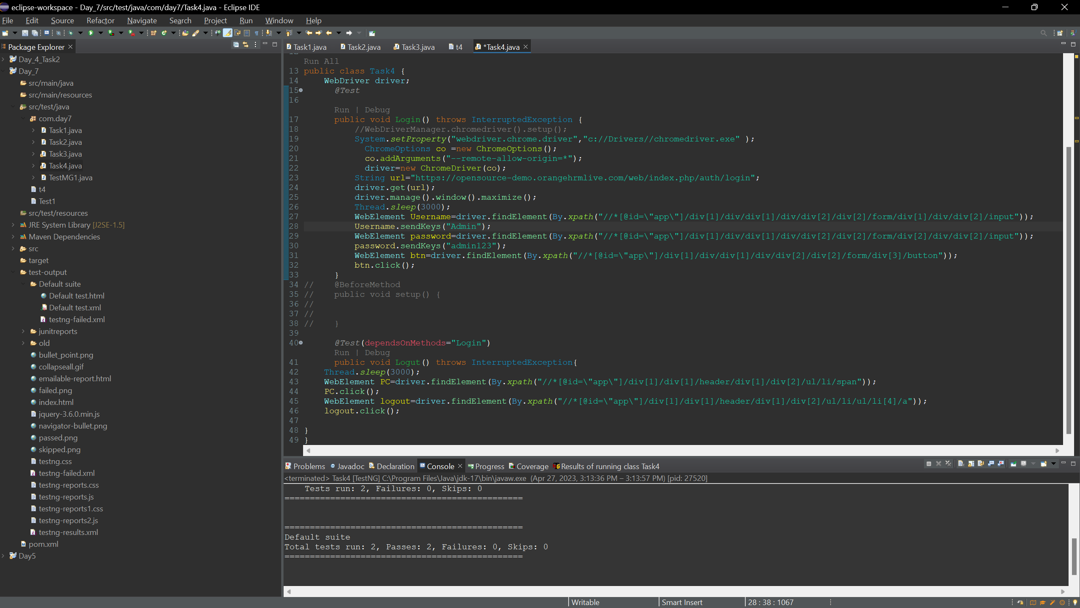

**Output:**

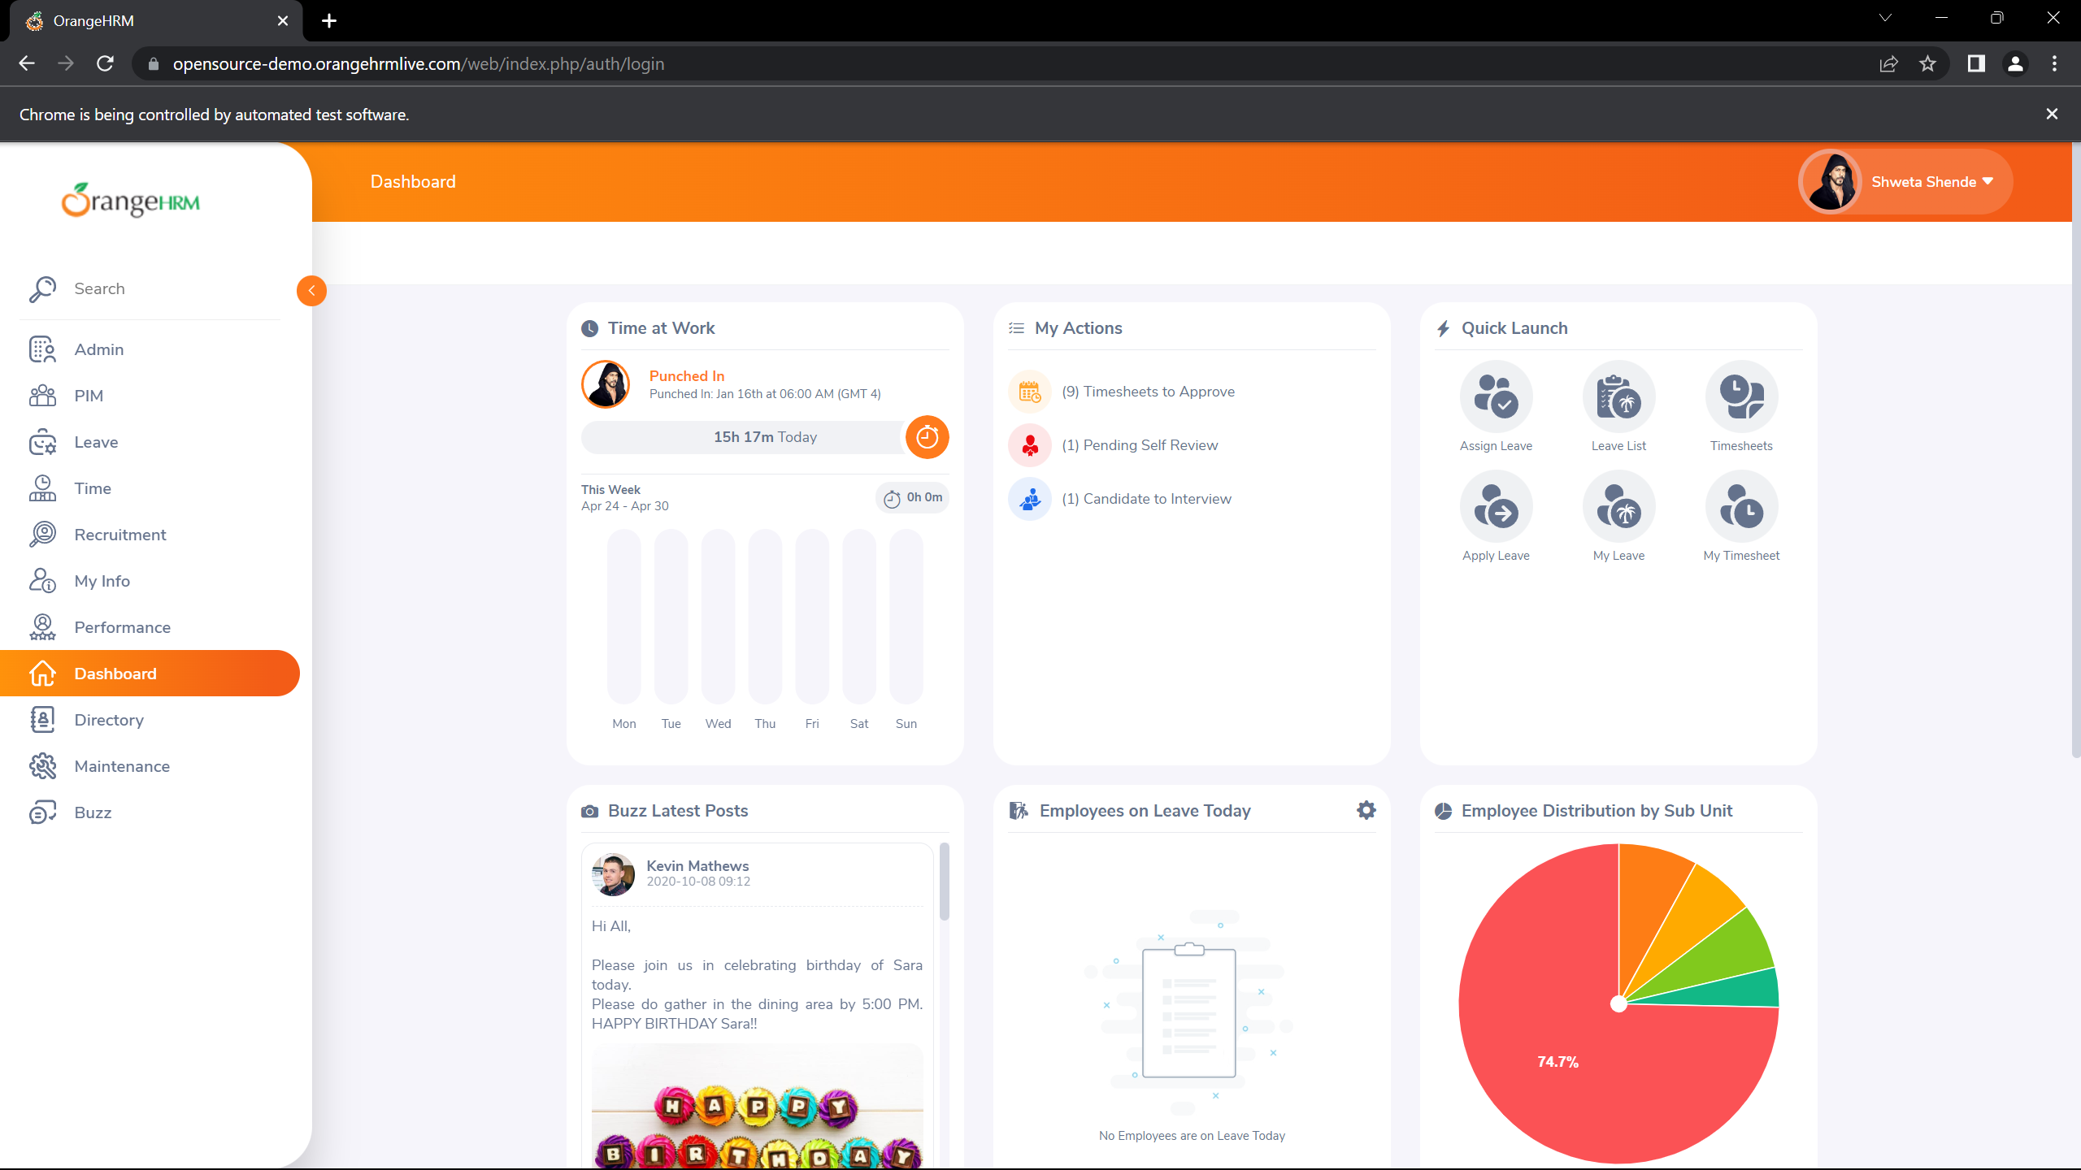

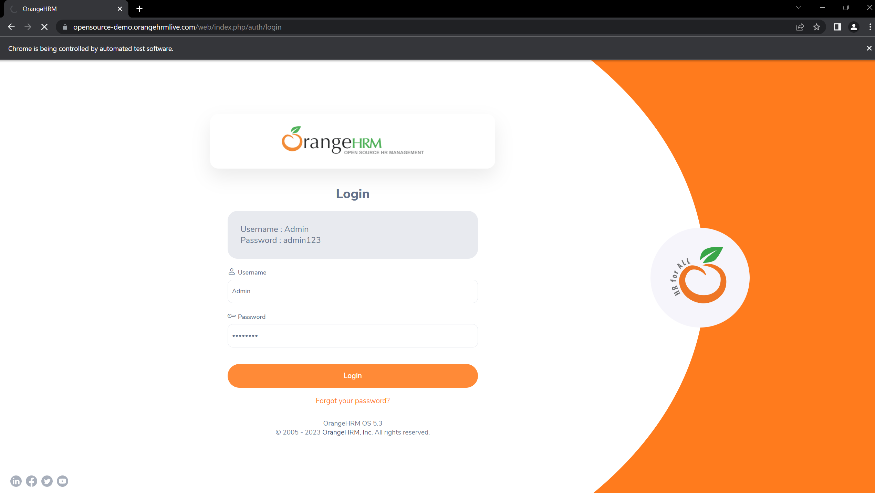**}**

**}**

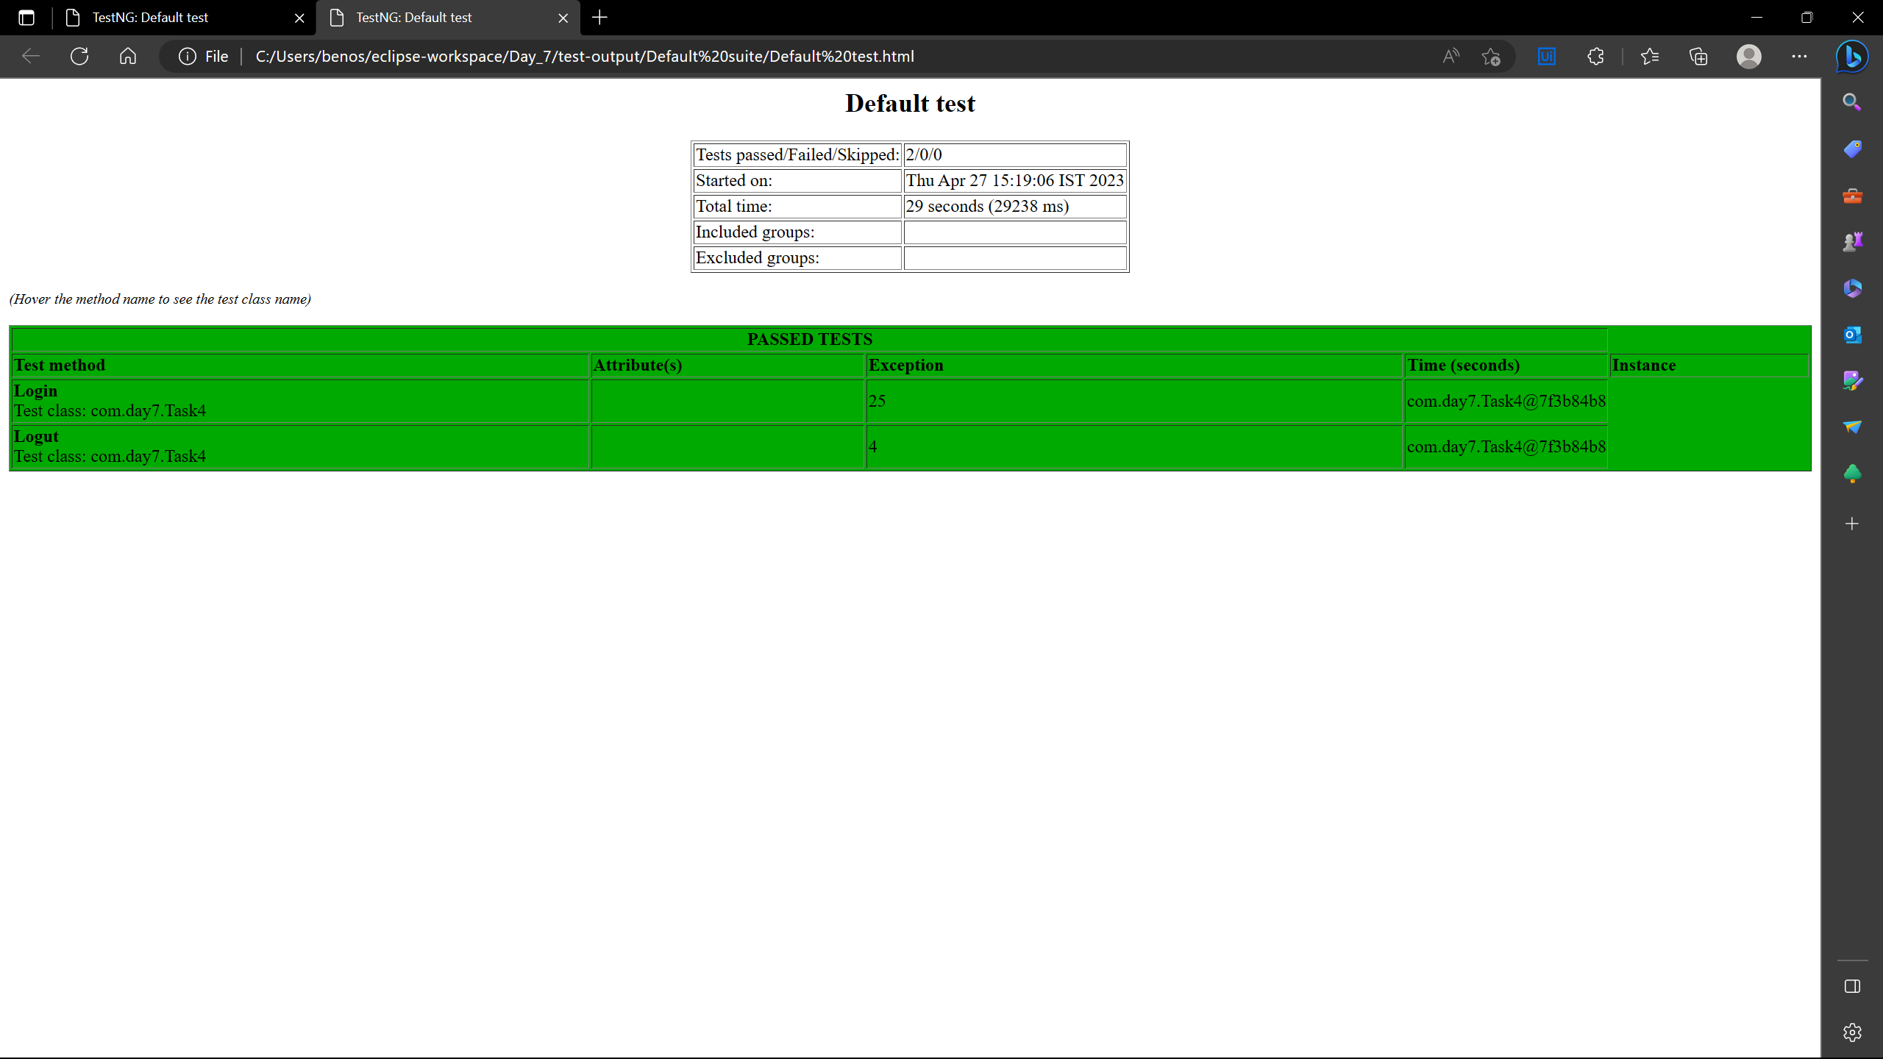

**Task 5:**

**subdivision 1**

package com.day7;

import org.openqa.selenium.WebDriver;

import org.openqa.selenium.chrome.ChromeDriver;

import org.openqa.selenium.chrome.ChromeOptions;

import org.testng.Assert;

import org.testng.annotations.Test;

public class Task5 {

//

*@Test*

public void Test() {

//WebDriverManager.chromedriver().setup();

System.*setProperty*("webdriver.chrome.driver","c://Drivers//chromedriver.exe" );

ChromeOptions co =new ChromeOptions();

co.addArguments("--remote-allow-origin=*");

WebDriver driver;

driver=new ChromeDriver(co);

String ur="https://www.godaddy.com/";

driver.get(ur);

driver.manage().window().maximize();

String title=driver.getTitle();

String expectedtitle="Domain Names, Websites, Hosting & Online Marketing Tools - GoDaddy IN";

Assert.*assertEquals*(title, expectedtitle);

String url=driver.getCurrentUrl();

String expec_url="https://www.godaddy.com/en-in";

Assert.*assertEquals*(url, expec_url);

}

}

**Output:**

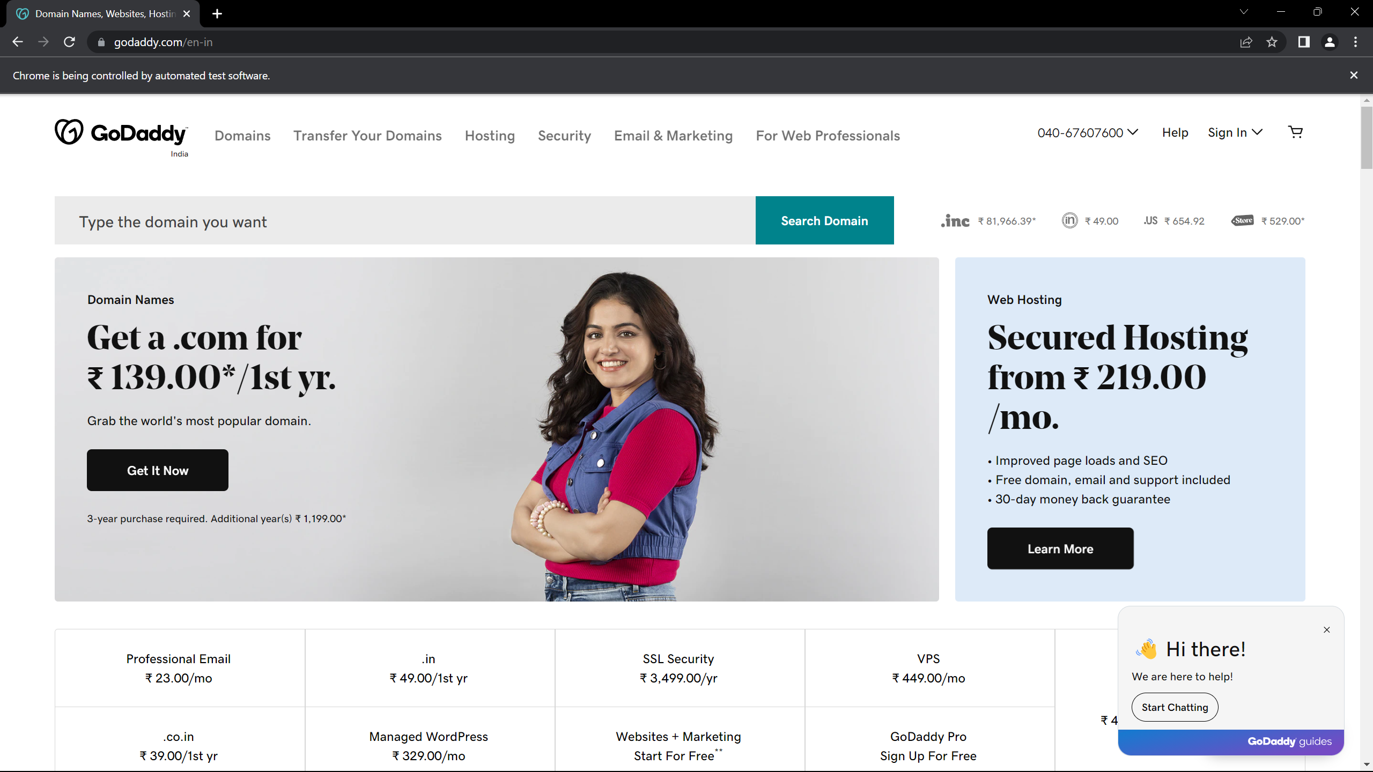

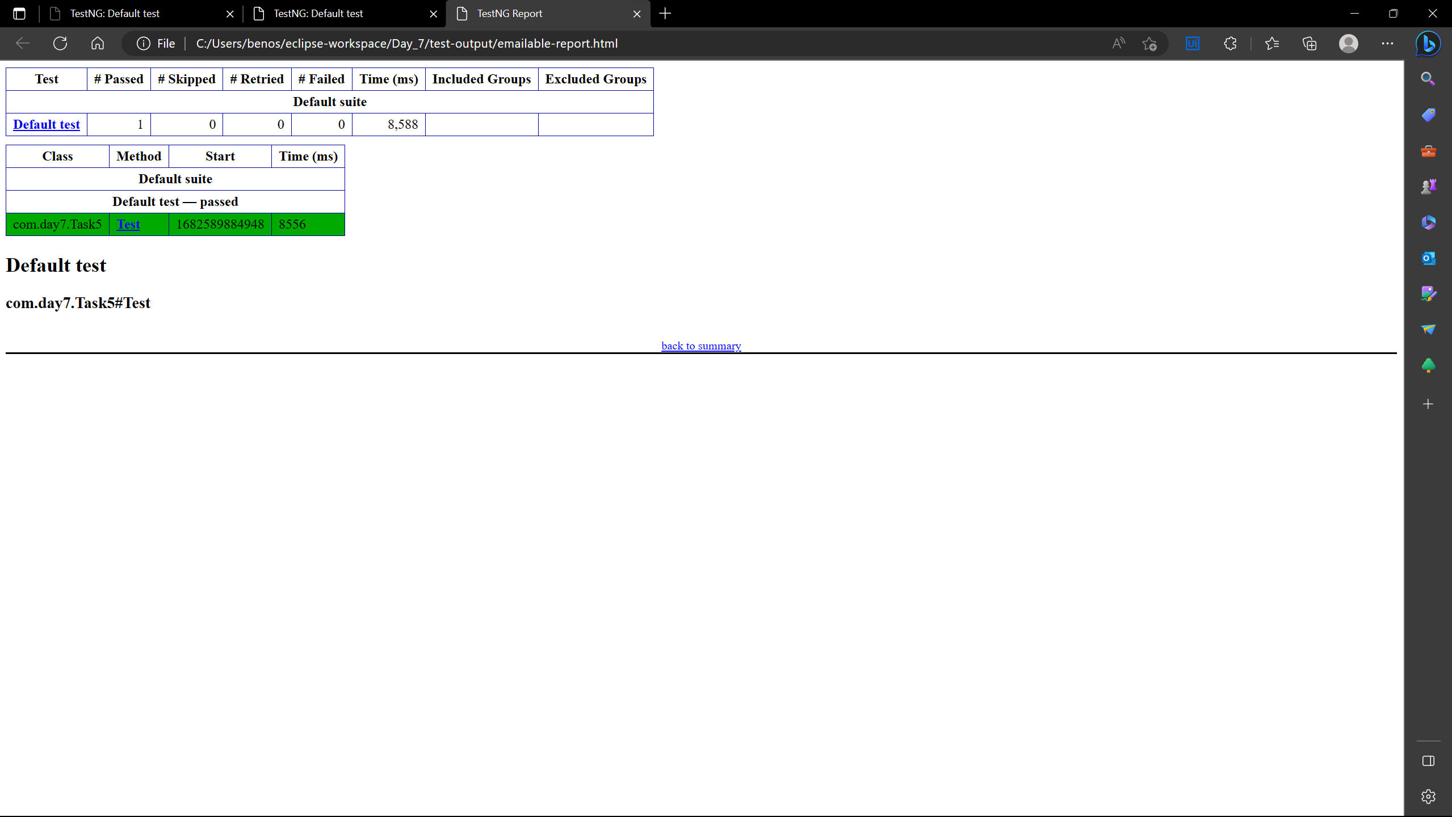

**subdivision 2:**

package com.day7;

import java.util.concurrent.TimeUnit;

import org.openqa.selenium.By;

import org.openqa.selenium.WebDriver;

import org.openqa.selenium.WebElement;

import org.openqa.selenium.chrome.ChromeDriver;

import org.openqa.selenium.chrome.ChromeOptions;

import org.testng.Assert;

import org.testng.annotations.BeforeSuite;

import org.testng.annotations.Test;

import io.github.bonigarcia.wdm.WebDriverManager;

public class Task5_2{

WebDriver driver;

*@BeforeSuite*

public void open()

{

//WebDriverManager.chromedriver().setup();

System.*setProperty*("webdriver.chrome.driver","c://Drivers//chromedriver.exe" );

ChromeOptions co =new ChromeOptions();

co.addArguments("--remote-allow-origin=*");

driver=new ChromeDriver(co);

}

*@Test*

public void Testcase_01() {

String ur="https://www.godaddy.com/";

driver.get(ur);

driver.manage().window().maximize();

String title=driver.getTitle();

String expectedtitle="Domain Names, Websites, Hosting & Online Marketing Tools - GoDaddy IN";

Assert.*assertEquals*(title, expectedtitle);

String url=driver.getCurrentUrl();

String expec_url="https://www.godaddy.com/en-in";

Assert.*assertEquals*(url, expec_url);

driver.quit();

}

*@SuppressWarnings*("deprecation")

*@Test*

public void Testcase_02()

{

//WebDriverManager.chromedriver().setup();

System.*setProperty*("webdriver.chrome.driver","c://Drivers//chromedriver.exe" );

ChromeOptions co =new ChromeOptions();

co.addArguments("--remote-allow-origin=*");

driver=new ChromeDriver(co);

String ur="https://www.godaddy.com/";

driver.get(ur);

driver.manage().window().maximize();

driver.manage().timeouts().~~implicitlyWait~~(1000,*TimeUnit*.***MILLISECONDS***);

// WebElement bn=driver.findElement(By.xpath("//*[@id=\"id-631b049a-e9c0-4d24-8710-c504745206dd\"]/button"));

// bn.click();

WebElement btn=driver.findElement(By.*xpath*("//*[@id=\"id-631b049a-e9c0-4d24-8710-c504745206dd\"]/div[2]/div[1]/ul/li[1]/button"));

btn.click();

WebElement dns=driver.findElement(By.*xpath*("//*[@id=\"id-631b049a-e9c0-4d24-8710-c504745206dd\"]/div[2]/div[1]/ul/li[1]/div/div[2]/div[1]/ul/li[2]/a"));

dns.click();

}

}

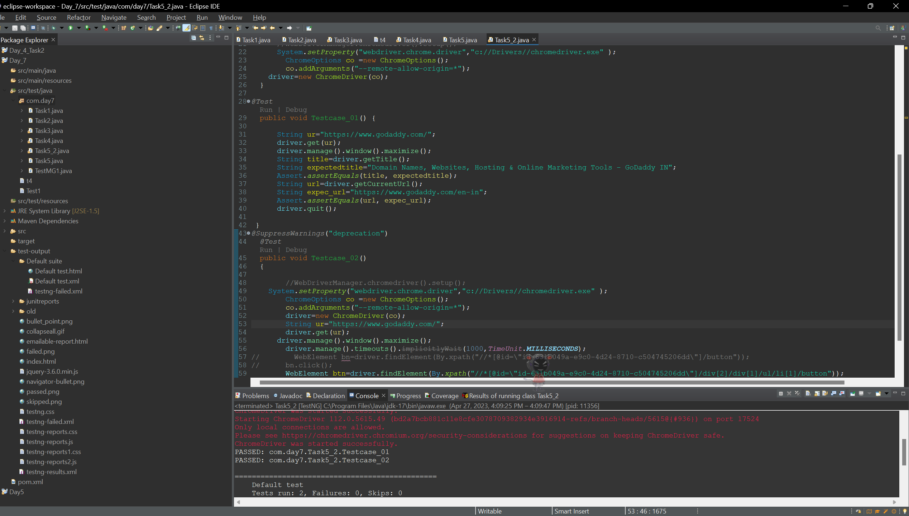

**Output:**

